**Wordpress deployment**

**Description:**

WordPress deployment refers to the process of transferring your WordPress website from a development or staging environment to a live, public-facing server. This involves making your website accessible to users and ensuring all files, databases, and configurations are correctly set up on the production server. This involves making your website accessible to users and ensuring all files, databases, and configurations are correctly set up on the production server.

**## Prerequisites**

- Linux-based server (Ubuntu or Amazon Linux recommended)

- SSH access to the server

- Basic knowledge of terminal commands

# Login into Amazon management console

## Select EC2

## Launch an instance

## Connect instance with gitbash using SSH

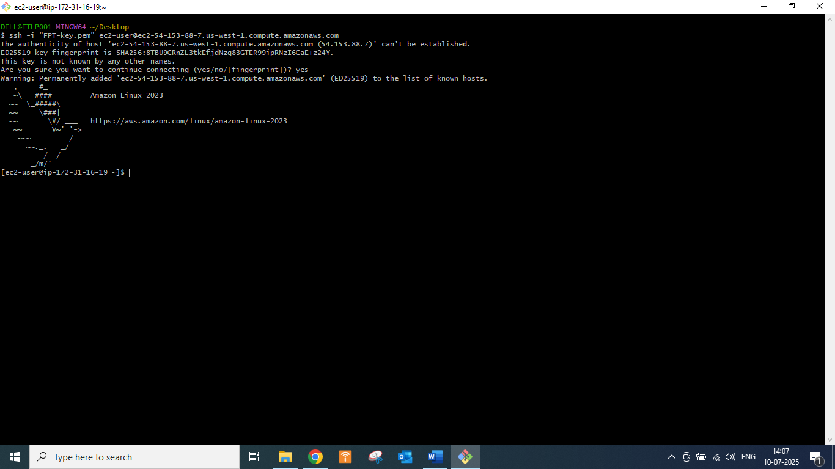

## Update System Packages

# Create lamp.sh file using vim

## sudo yum update **-y**

sudo yum install httpd mariadb105-server php **-y**

sudo systemctl **start** httpd mariadb php-fpm

sudo systemctl **enable** httpd mariadb php-fpm

# Press :wq to save and quit frim vim mode

# Have to do chmod +x lamp.sh to give executable permission

## Run the file by command ./lamp.sh

## We have to change the directory to /var/www/html/

## sudo wget <https://wordpress.org/latest.tar.gz>

# ls

## sudo tar -xvzf file name to untar

## sudo rm -rf latest.tar.gz

## cd wordpress

## [ec2-user@ip-172-31-16-19 wordpress]$ ls

index.php readme.html **wp-admin** wp-comments-post.php **wp-content** **wp-includes** wp-load.php wp-mail.php wp-signup.php xmlrpc.php

license.txt wp-activate.php wp-blog-header.php wp-config-sample.php wp-cron.php wp-links-opml.php wp-login.php wp-settings.php wp-trackback.php

[ec2-user@ip-172-31-16-19 wordpress]$

Need to install the connector

[ec2-user@ip-172-31-16-19 wordpress]$ sudo yum install php8.4-mysqlnd.x86_64

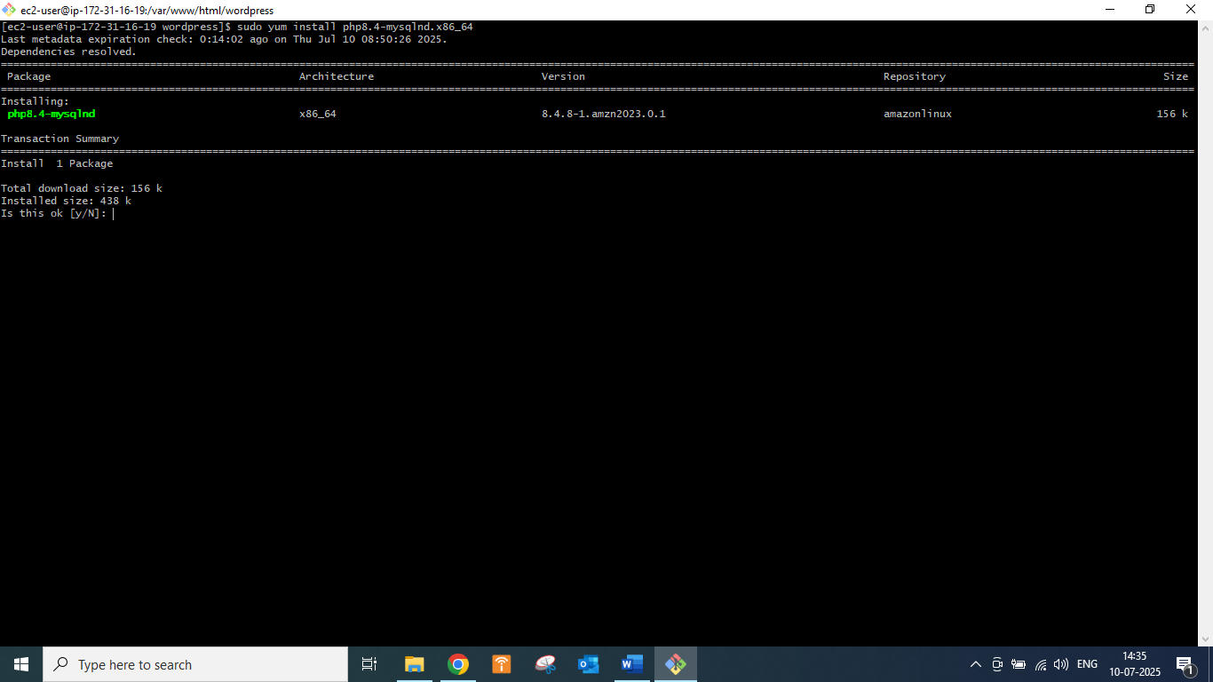

Now hit the public ip in browser

## A screenshot of a computer

AI-generated content may be incorrect.

## [ec2-user@ip-172-31-16-19 ~]$ sudo mysql

MariaDB [(none)]> alter user root@localhost identified by "root";

MariaDB [(none)]> create database wordpressdb;

MariaDB [(none)]> show databases;

+--------------------+

| Database |

+--------------------+

| information_schema |

| mysql |

| performance_schema |

| wordpressdb |

+--------------------+

**4 rows in set (0.001 sec)**

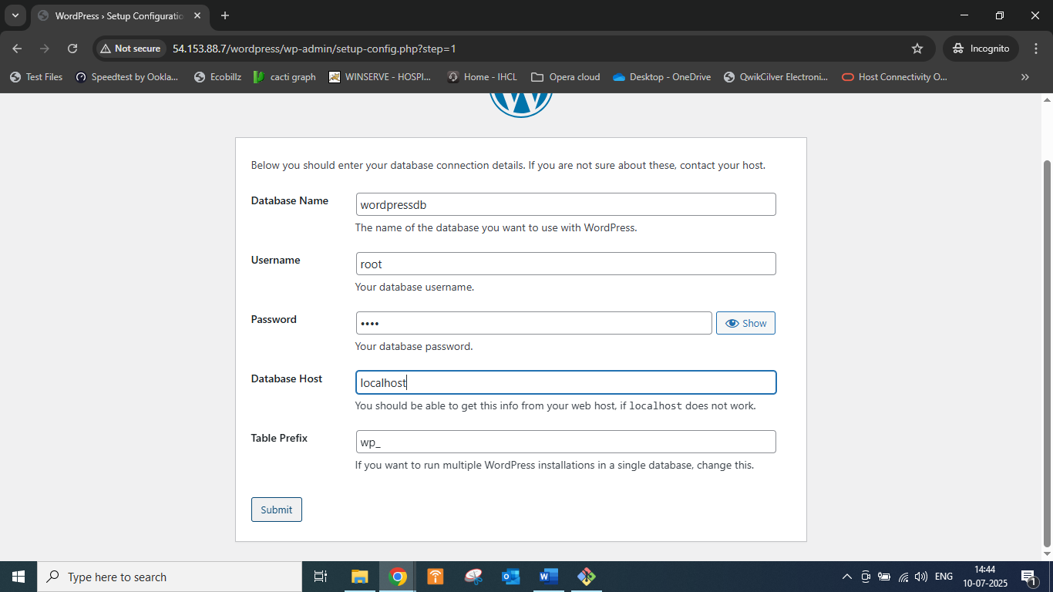

[ec2-user@ip-172-31-16-19 ~]$ cd /var/www/html/

[ec2-user@ip-172-31-16-19 html]$

[ec2-user@ip-172-31-16-19 html]$ sudo chmod -R 777 wordpress/

